**Project Development Phase**

**Jira**

|  |  |
| --- | --- |
| Date | 15 November 2022 |
| Team ID | PNT2022TMID29985 |
| Project Name | AI- Fertilizers recommendation system for disease prediction |

Roadmap

EPICS:

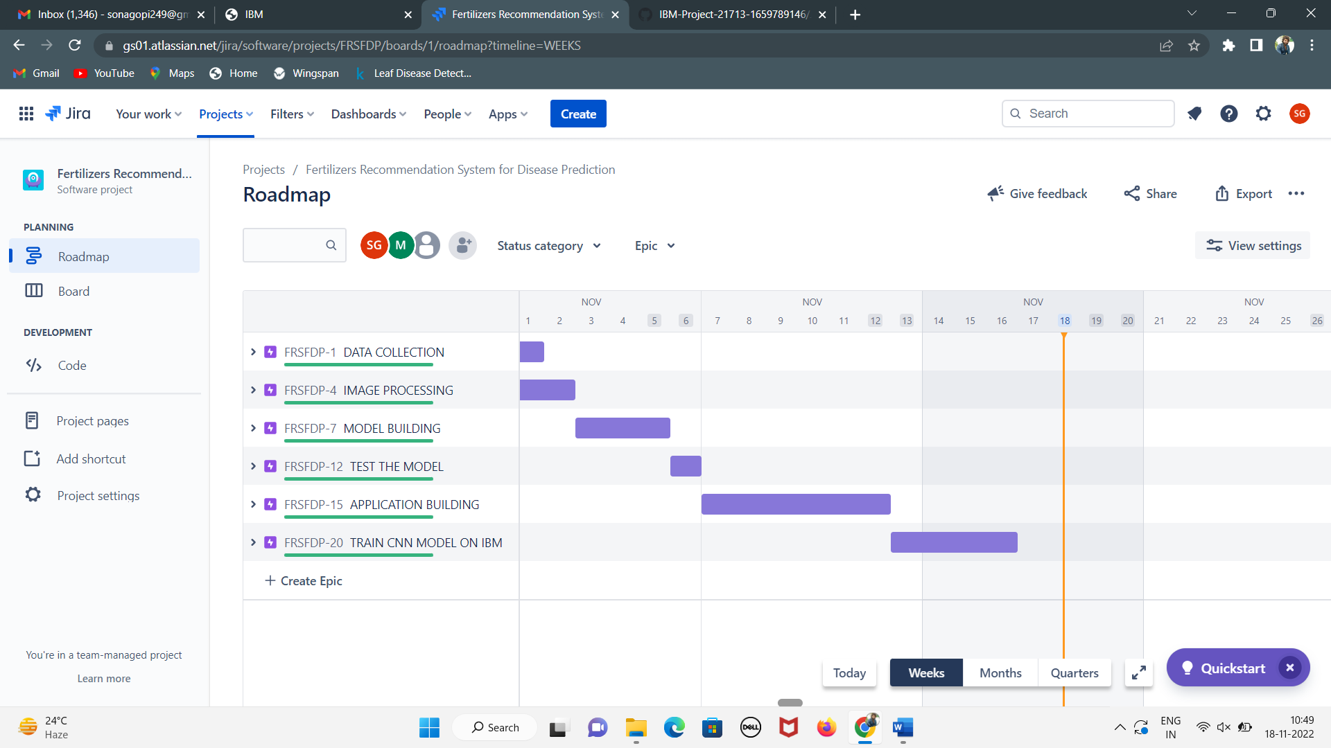

DATA COLLECTION AND IMAGE PREPROCESSING

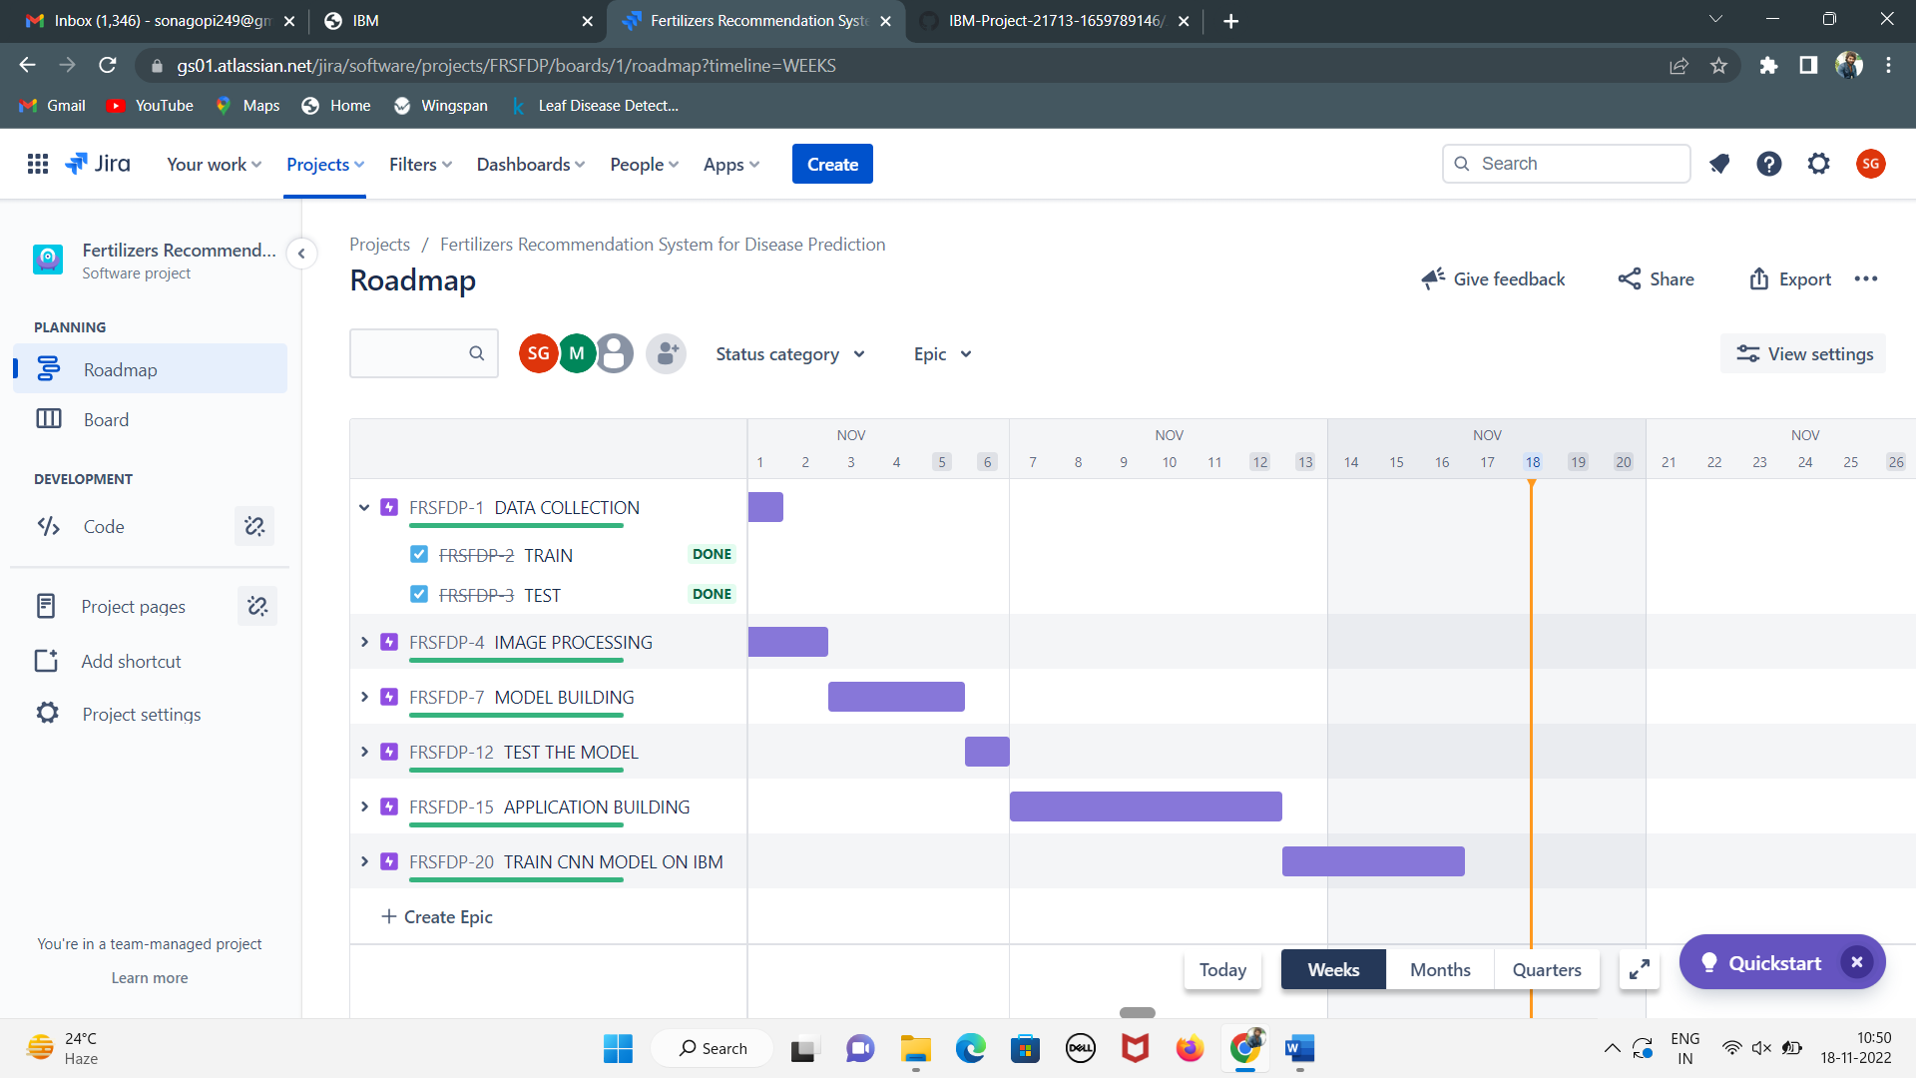

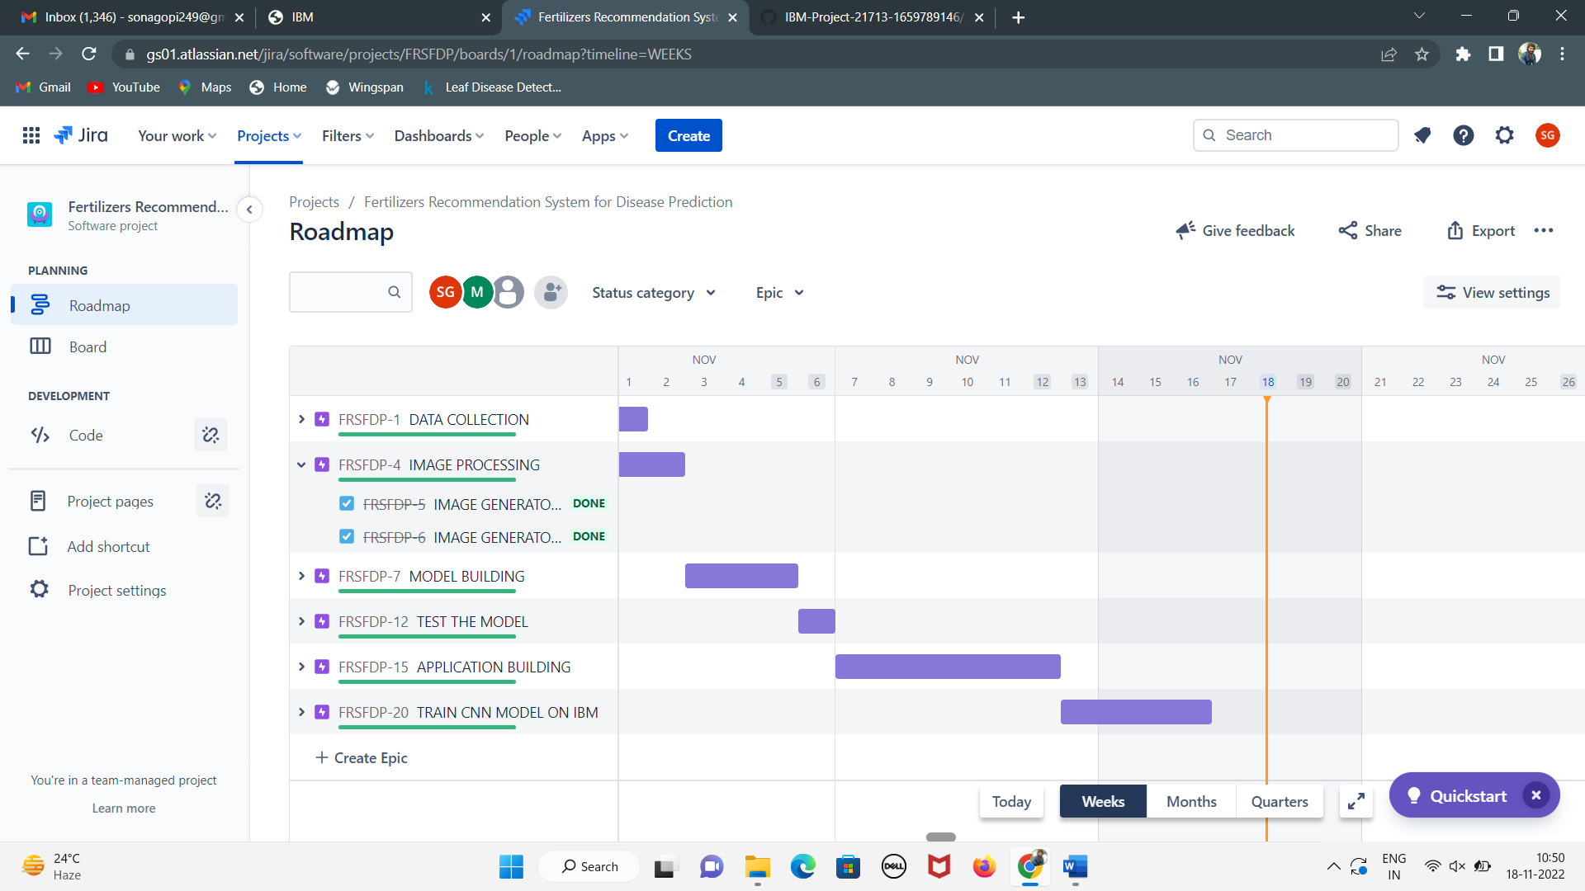

MODEL BUILDING

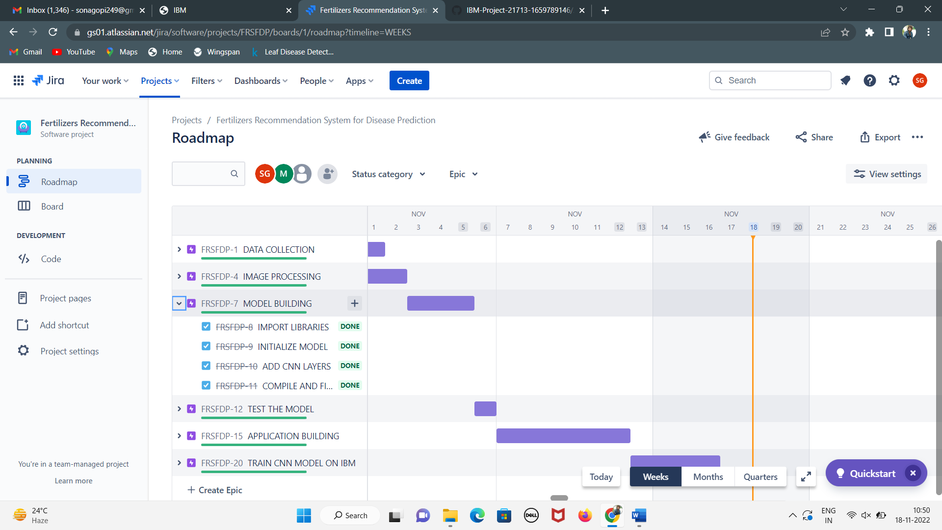

TEST THE MODEL AND APPLICATION BUILDING

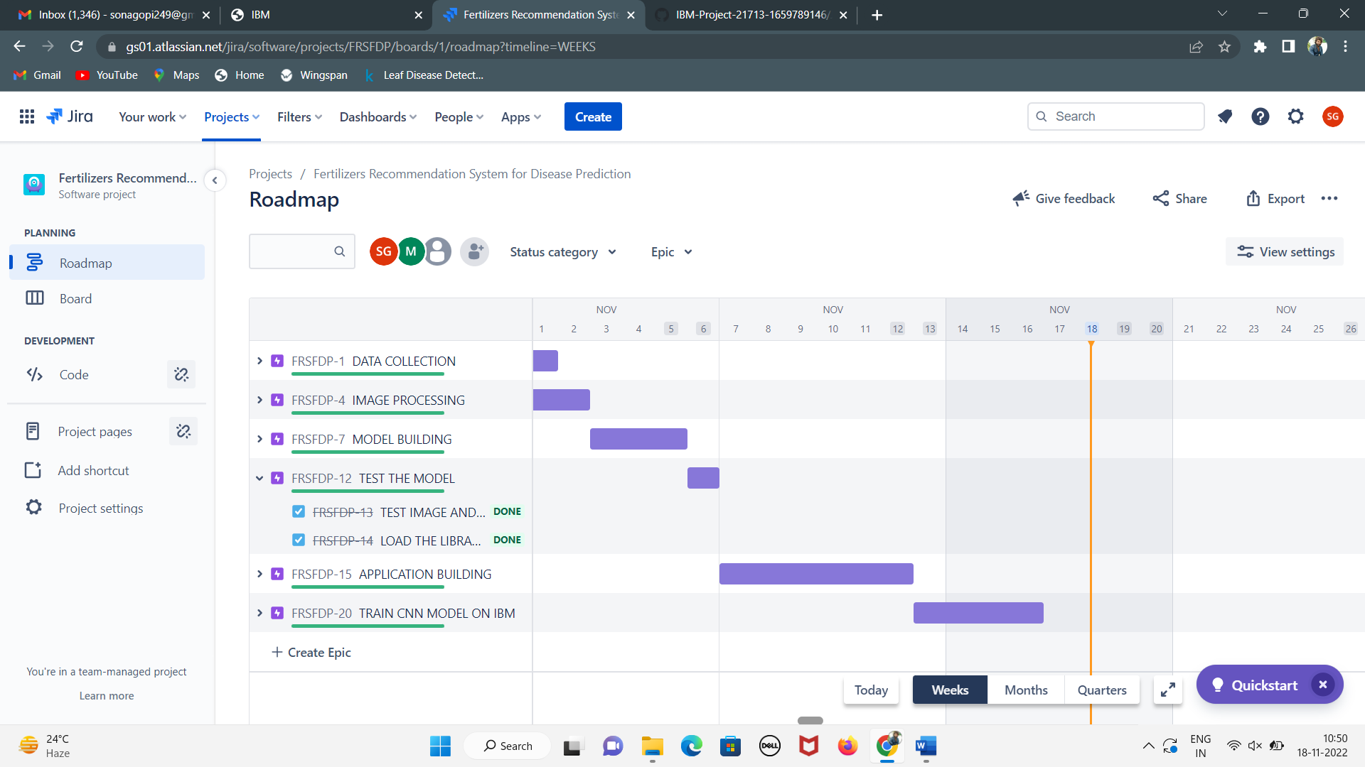

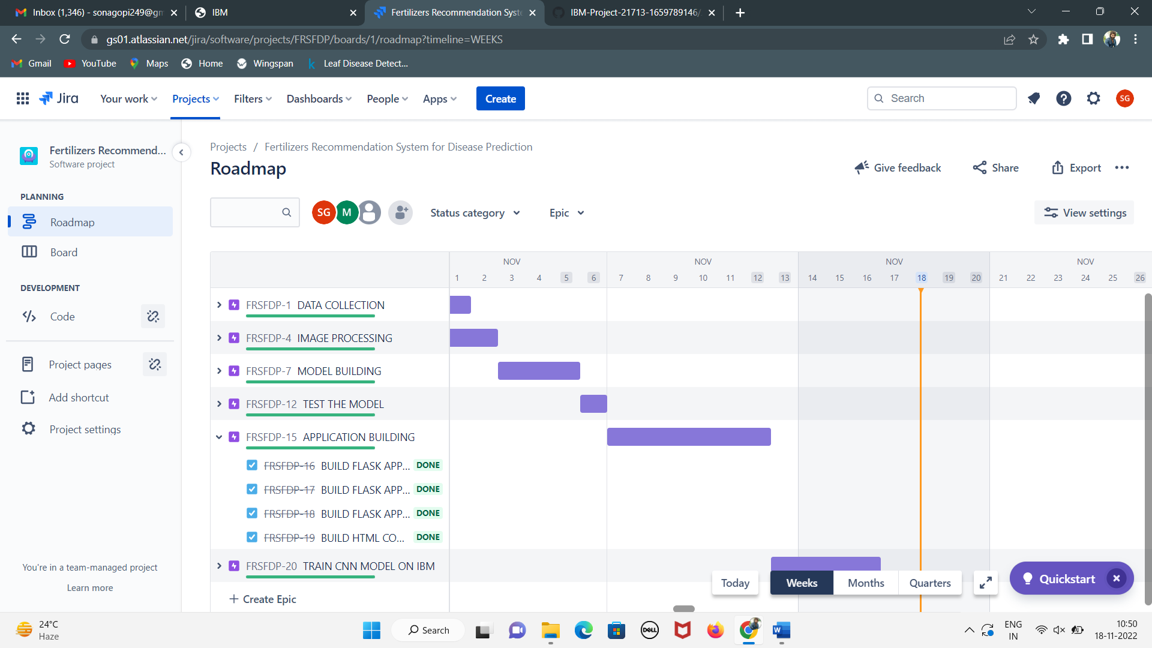

TRAIN CNN MODEL ON IBM

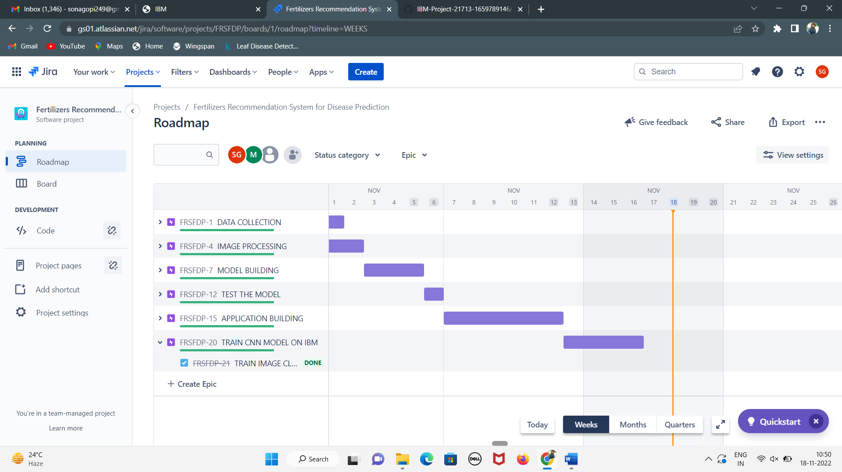

FRSFDP Board

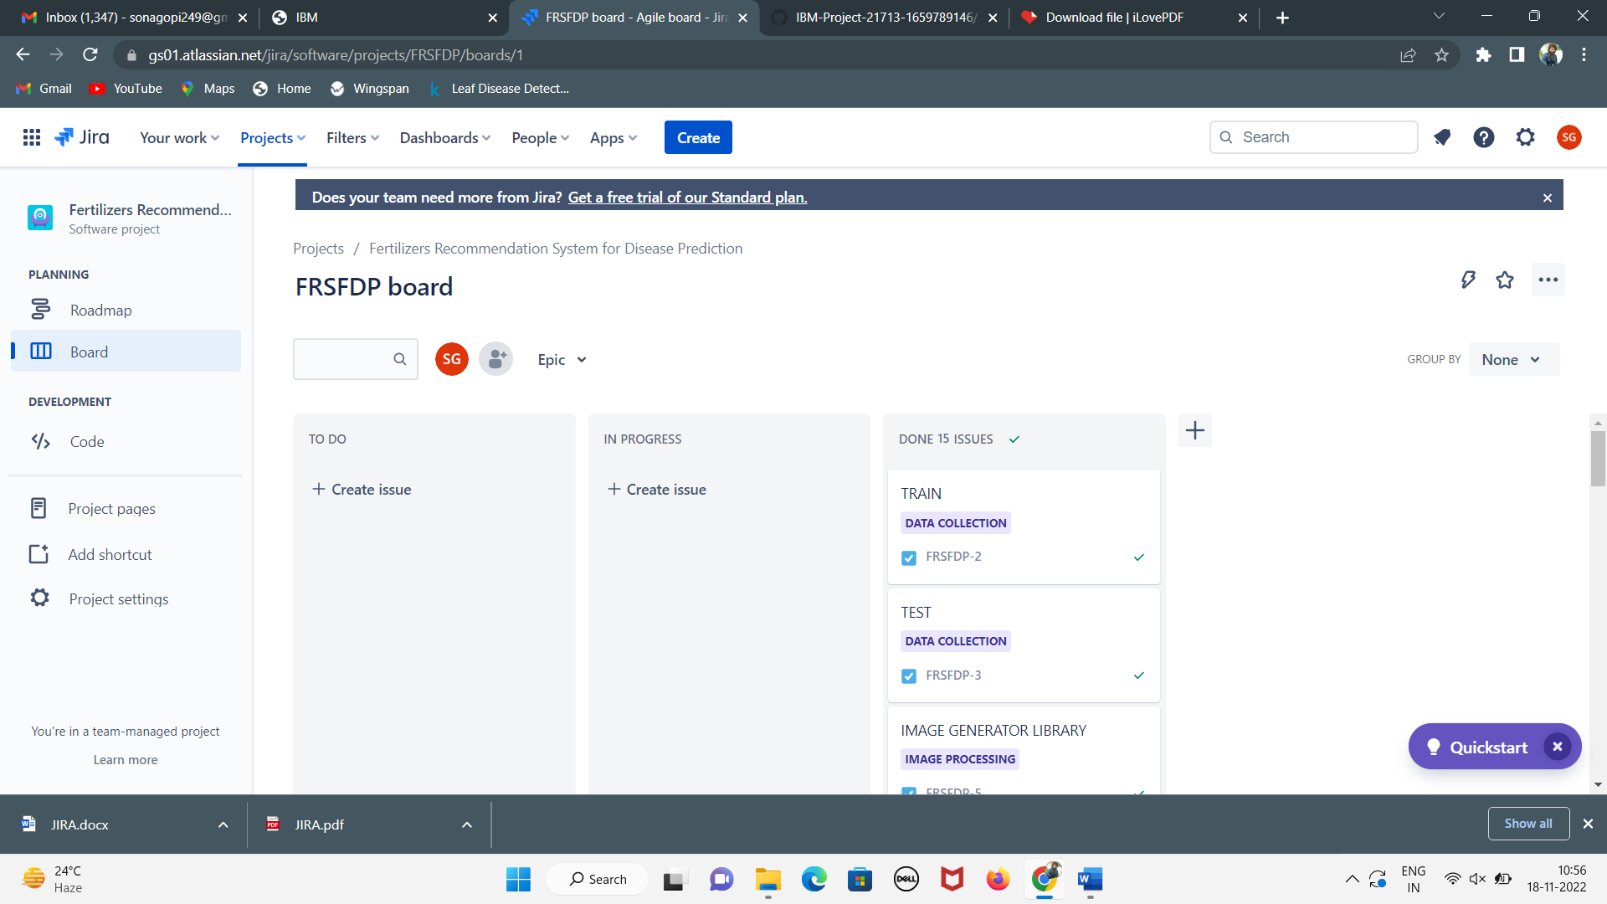

**Team ID :** PNT2022TMID29985

**Team Size :** 4

**Team Leader :** SONAKSHI G

**Team member :** SINDHU S

**Team member :** JAGATHI S

**Team member :** MANUSHA R